Application Form - The Gift of PR

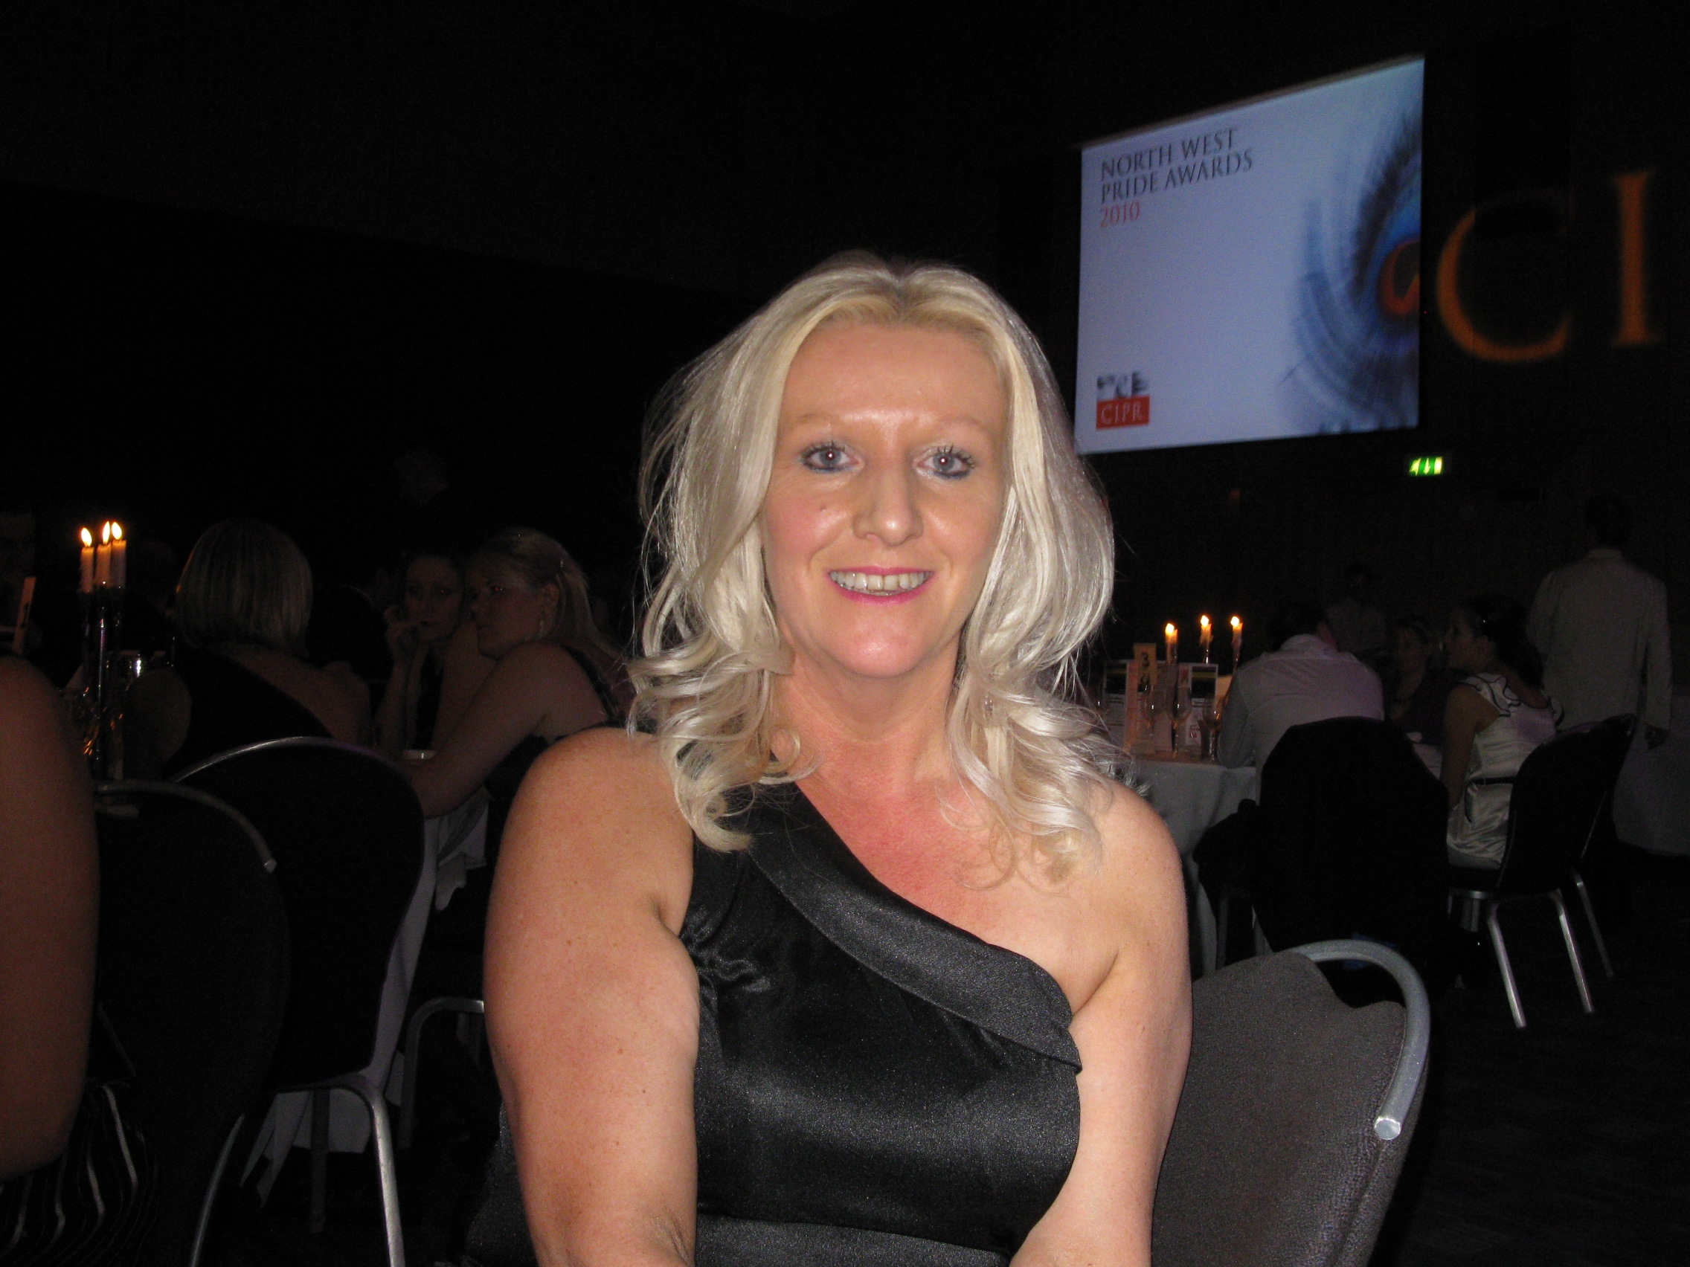

A prize of £600 of PR time is on offer from the country’s ‘Best Freelance PR Practitioner’, Jane Hunt, for a worthy cause such as a charity or community trust that can best demonstrate why promotion through PR would benefit them.

Please complete the form and email back to jane@catapultpr.co.uk by December 30, 2012. A panel will then judge the entries and award the prize in early January 2013, which could give your cause a great kickstart to the year.

- Please give the background to your charity, community organisation or cause? (150 words max)

- Why do you think your cause deserves this prize of free PR time to help you promote what you do? (200 words max)

- Would you envisage using the time to gain publicity in the media, to communicate with other target audiences, or to use for copywriting (you could mix these, if you wished). Please give your thoughts (100 words max)

- What challenges have you faced in the past when marketing your cause? (Up to 300 words max).

5. Do you have a registered charity number ? Yes No

If ‘yes’, please give it here _____________________________________________________________

6. Do you have a website? If so, please give its web address

7. Please give the contact details of the person submitting the application:

Name:

Personal Address:

Name of Cause/Charity:

Address of Cause/Charity:

Position in which you
represent this cause:

Best telephone contact number:

Email address:

Addendum:

Should any false representation be discovered to have been made in making this application, Jane Hunt and Catapult Public Relations Limited reserve the right to withdraw any offer of support. The judges’ decision as to how to award the PR time is final.

Signature: Please sign this application. In so doing, you are committing to having submitted true and accurate information about your charity/cause.

________________________________________

Date of signature: _________________

Should you wish to post back your form, please send it to:

The Keep, 30 Castle Avenue, Carleton, Poulton-le-Fylde, Lancashire, FY6 7NW

